SIR APOLLO
MID TERM III EXAMINATION 2023
TOP CLASS: (5 – 6 YEARS)
LEARNING AREA 4: MATHEMATICAL CONCEPTS

My name is: ……………………………………………………………….
My School is: …………………………………….………………………..
I am in: ………………………………..…………………………….…………………..
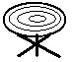1. Count and write the number word.
=________
=________
=________

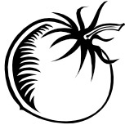
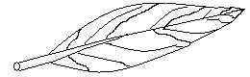
=_______
2. Fill in the missing numbers.
_____
9
_____
11
7
_____
13
____
15
3. Write the number after.
(a) 4, ____ (c) 9, ____
(b) 6, ____ (d) 15, ____
4. Name the shapes.

___________ __________ ________ _______
5. Read and draw
three pencils eight balls ten flowers

6. Match picture to the word.
empty

half

full

7. Add (+)
(a) 3 + 1 = ___ (c) 4 + 0 = ___

(b) 2 + 2 + 2 = ___ (d) 3 + 4 + 2= __

(f) 2
(e) 5 4
+ 3 + 4

Three plus two equals______________________

8. Arrange the numbers in order.
(a) 2, 4, 3, 5 = _____________________
(b) 0, 2, 1, 3 = ______________________
(c) 9, 8, 7, 6 = ______________________
9. Take away (-).
(a) = ___

(b) 5 – 2 =____ (d) 7 – 3 = ____

(c) 9 (e) 8
- 6 - 8

(f) Six minus two equals__________________
10. Circle the less number.
(a) 3 , 5 (b) 1 , 4
(c) 6 , 2 (d) 5 , 9
11. Circle the correct word for the number.
4
9
7
5
four
for
foru
neni
nine
nnie
senve
seven
vesen
vefi
five
fiev

END

